# CSS Box Model and Typography – Exercise

## Topics Covered

Everything in CSS has a box around it, and understanding these boxes is key to being able to create more complex layouts with CSS, or to align items with other items. In this lesson, we will take a look at the CSS *Box Model*. You'll get an understanding of how it works and the terminology that relates to it.

## Resources

* **The Box Model**
  + <https://developer.mozilla.org/en-US/docs/Learn/CSS/Building_blocks/The_box_model>
* **Typography**
  + <https://developer.mozilla.org/en-US/docs/Learn/CSS/Styling_text/Fundamentals>
* **Position**
  + <https://developer.mozilla.org/en-US/docs/Learn/CSS/CSS_layout/Positioning>

## Tasks

### Box Model Visualised

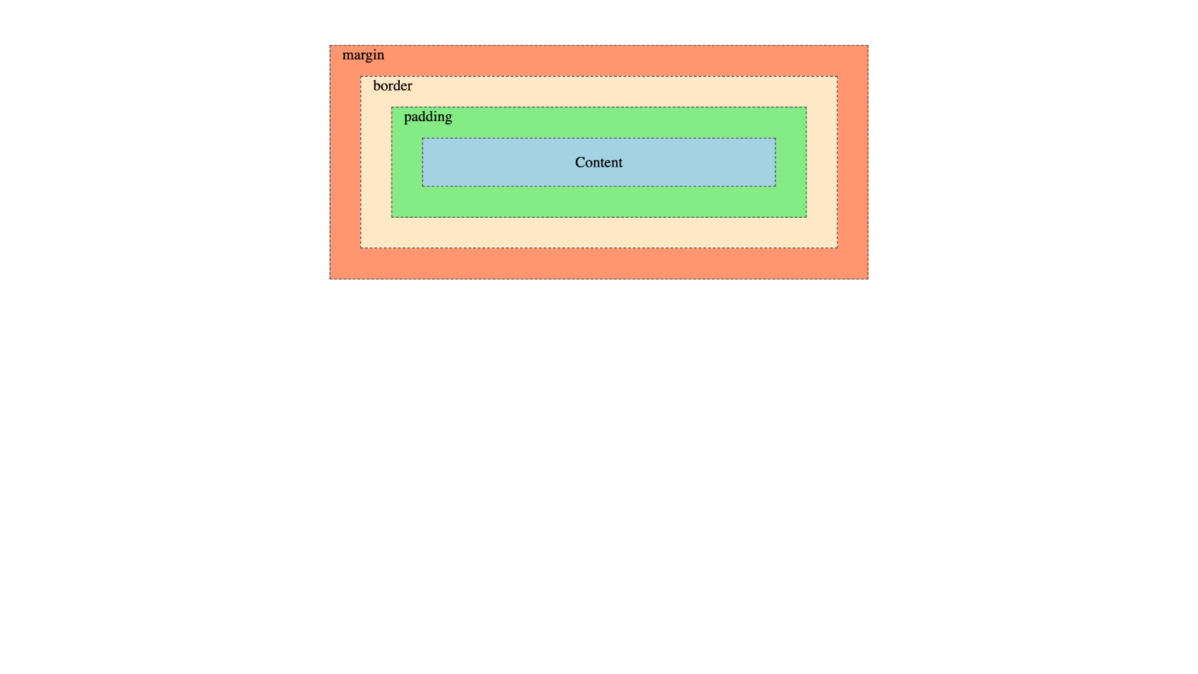

*For full screenshot check the screenshot.png file in the folder for the task*

#### Objective:

Create a webpage that looks like the screenshot above.

#### Requirements:

1. **File Setup**:
   * Create an **HTML** document named **box-model-visualised.html**
   * Create a **CSS** file named **box-model-visualised.css**

### Layout – Centered Container

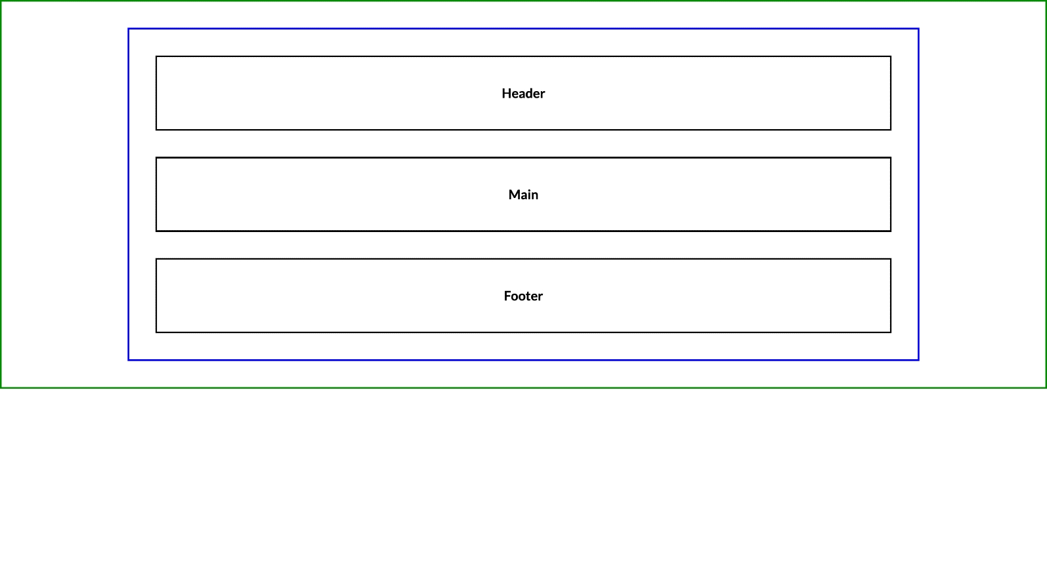

*For full screenshot check the screenshot.png file in the folder for the task*

#### Objective:

Create a webpage that looks like the screenshot above.

#### Requirements:

1. **File Setup**:
   * Create an **HTML** document named **layout-centered-container.html**
   * Create a **CSS** file named **layout-centered-container.css**

### Layout – Section and Wrapper

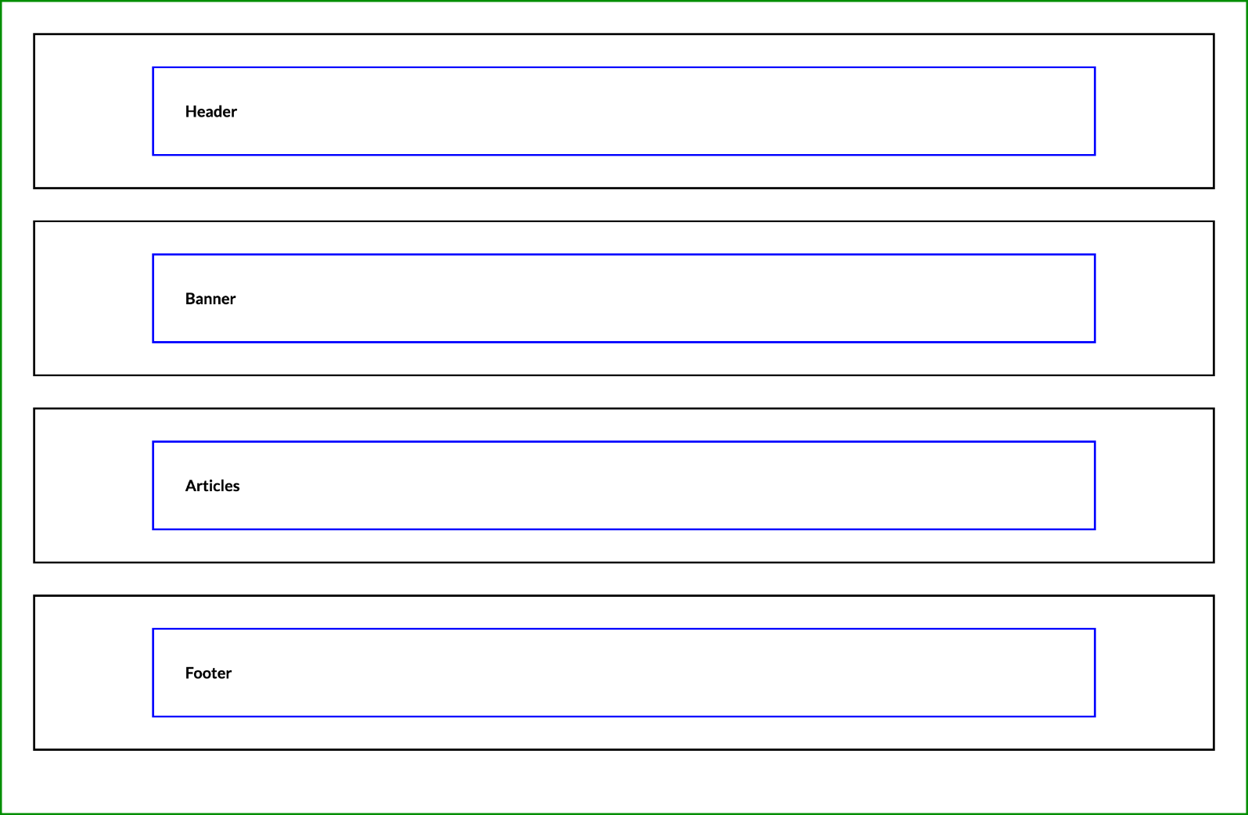

*For full screenshot check the screenshot.png file in the folder for the task*

#### Objective:

Create a webpage that looks like the screenshot above.

#### Requirements:

1. **File Setup**:
   * Create an **HTML** document named **layout-section-and-wrapper.html**
   * Create a **CSS** file named **layout-section-and-wrapper.css**

### Component: Card

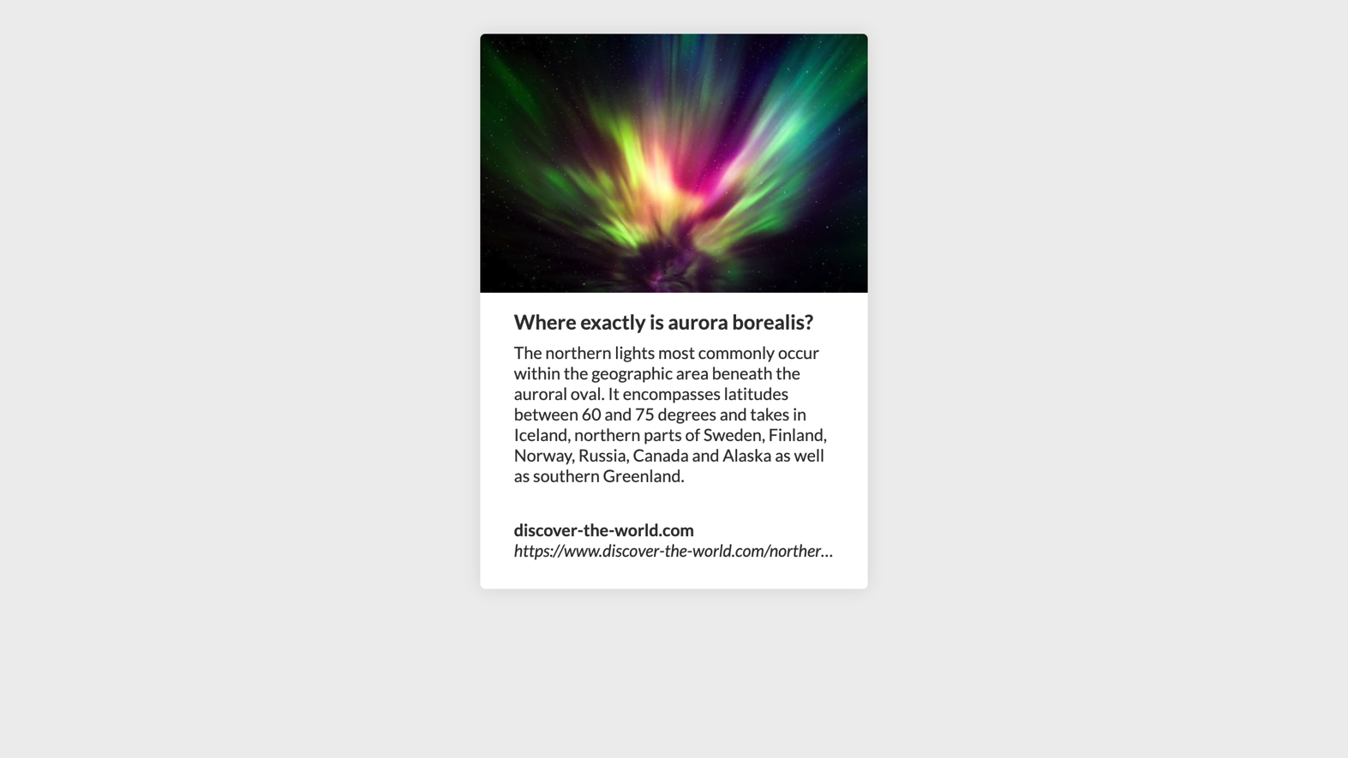

*For full screenshot check the screenshot.png file in the folder for the task*

#### Objective:

Create a webpage that looks like the screenshot above.

#### Requirements:

1. **File Setup**:
   * Create an **HTML** document named **component-card.html**
   * Create a **CSS** file named **component-card.css**

### Blog Post

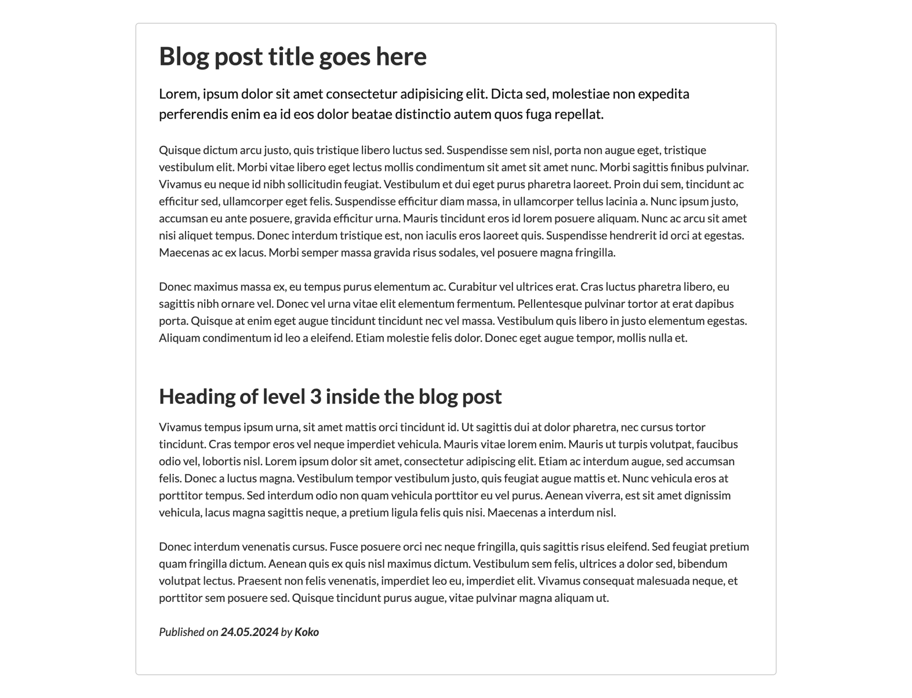

*For full screenshot check the screenshot.png file in the folder for the task*

#### Objective:

Create a webpage that looks like the screenshot above.

#### Requirements:

1. **File Setup**:
   * Create an **HTML** document named **blog-post.html**
   * Create a **CSS** file named **blog-post.css**
   * Copy reset.css file from Lecture 3
   * Copy **typography.css** file from Lecture 3
2. **Tips**
   * Override font family styling from typography css with Lato, sans-serif
   * Create a container element to center the layout and set max-width

### Component: Accordion

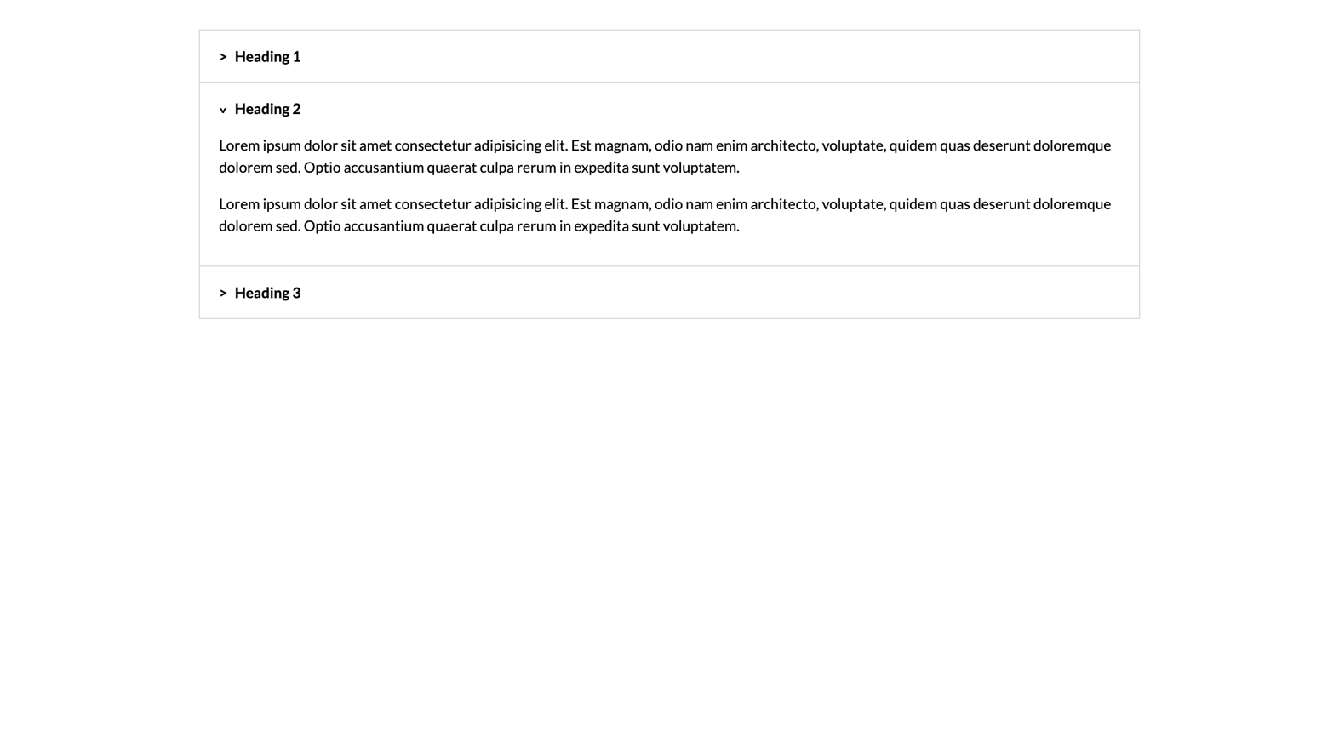

*For full screenshot check the screenshot.png file in the folder for the task*

#### Objective:

Create a webpage that looks like the screenshot above.

#### Requirements:

1. **File Setup**:
   * Create an **HTML** document named **component-accordion.html**
   * Create a **CSS** file named **component-accordion.css**
2. **Tips**
   * Use details and summary elements to achieve the open/close effect

### Social Media Icons

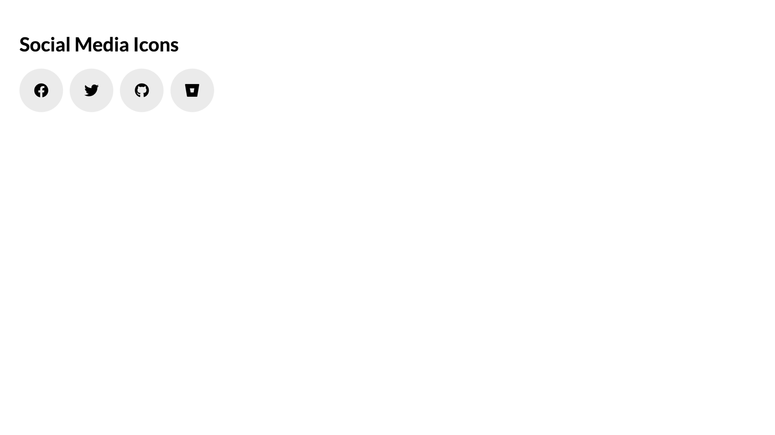

*For full screenshot check the screenshot.png file in the folder for the task*

#### Objective:

Create a webpage that looks like the screenshot above.

#### Requirements:

1. **File Setup**:
   * Create an **HTML** document named **social-media-icons.html**
   * Create a **CSS** file named **social-media-icons.css**
   * Include Font Awesome by using the following link:
     1. https://cdnjs.cloudflare.com/ajax/libs/font-awesome/6.4.2/css/all.min.css

### Component: Button

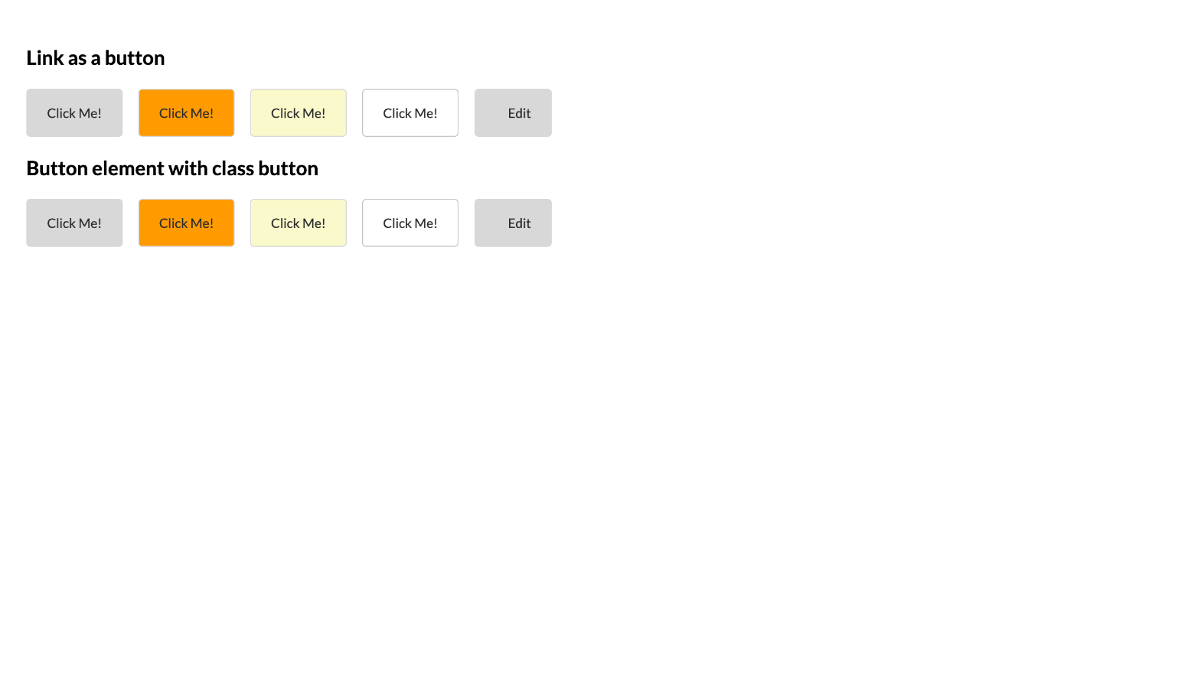

*For full screenshot check the screenshot.png file in the folder for the task*

#### Objective:

Create a webpage that looks like the screenshot above.

#### Requirements:

1. **File Setup**:
   * Create an **HTML** document named **component-button.html**
   * Create a **CSS** file named **component-button.css**
   * Include Font Awesome by using the following link:
     1. https://cdnjs.cloudflare.com/ajax/libs/font-awesome/6.4.2/css/all.min.css

### Component: Banner

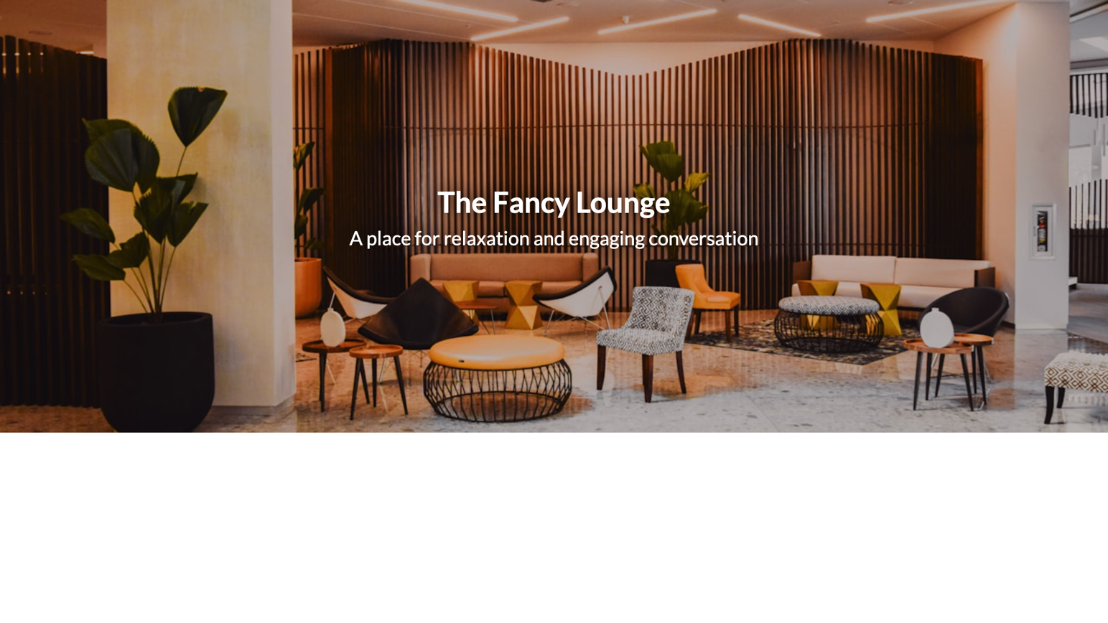

*For full screenshot check the screenshot.png file in the folder for the task*

#### Objective:

Create a webpage that looks like the screenshot above.

#### Requirements:

1. **File Setup**:
   * Create an **HTML** document named **component-banner.html**
   * Create a **CSS** file named **component-banner.css**
2. **Tips**
   * Use min-height to set height on the banner
   * Use background image on a section element that spans the entire width of the document
   * Use background-size and background-position to place the image in the center and make sure it will always fill its container
   * Use position absolute for the header text section to place it in the center of the banner